C-Programming
Assignment-2
1.Merge two sorted arrays

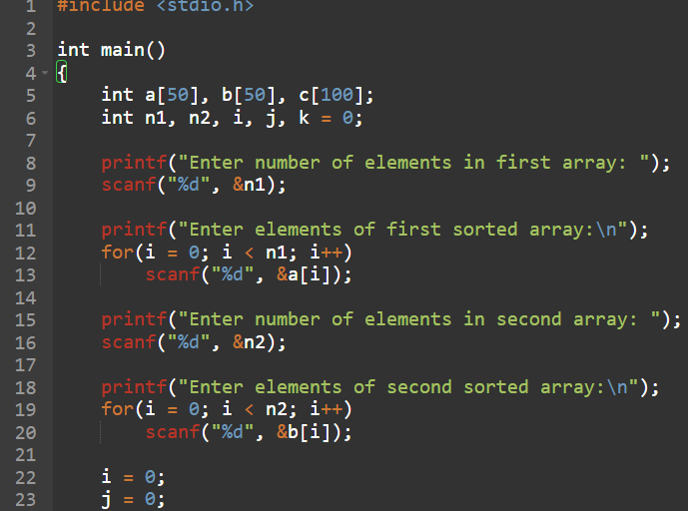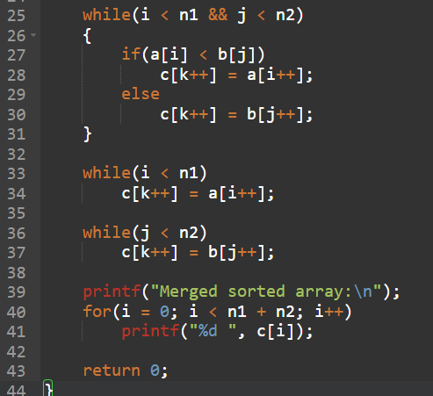
Output:

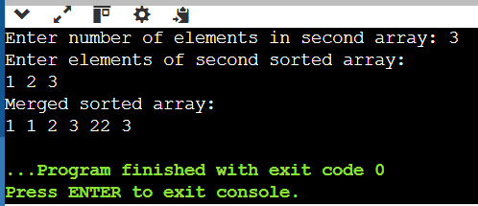

2. Delete a given element in an array
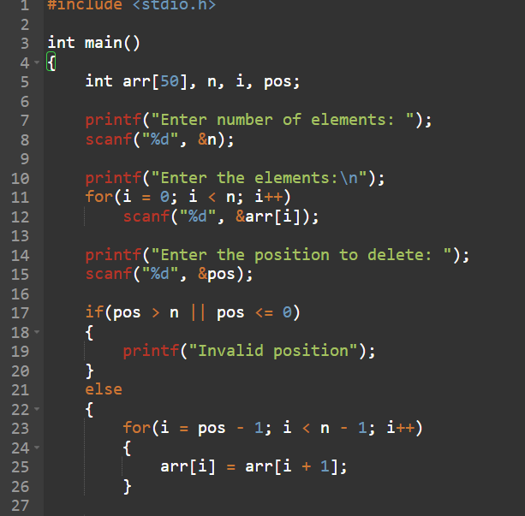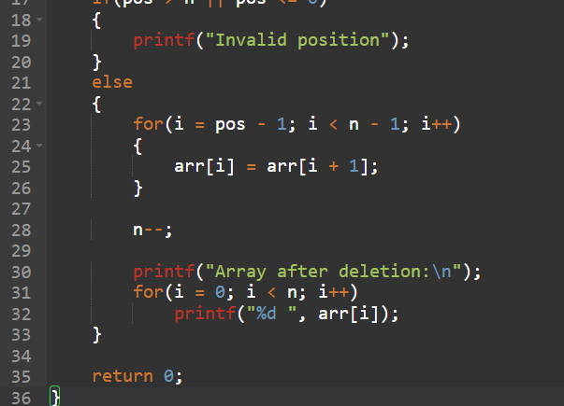

Output:

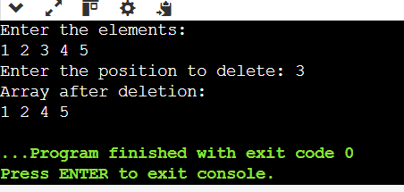

3. Insert an element in the desired index in an array

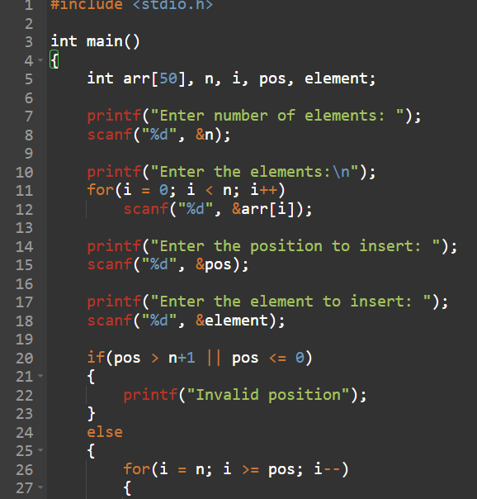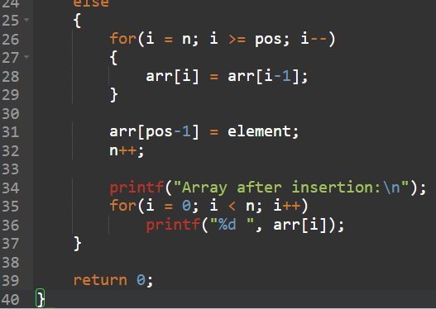

Output:
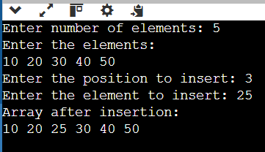

4. Write a program to find the number of composite numbers in an array of elements
Sample Input;:
Array of elements = {16, 18, 27, 16, 23, 21, 19}
Sample Output:
Number of Composite Numbers = 5

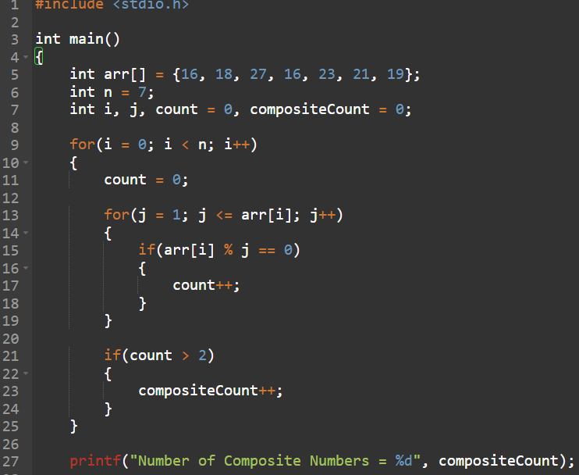

Output:

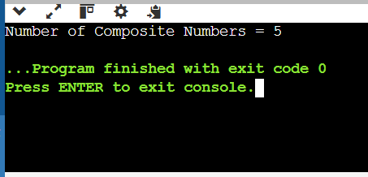

5. Write a program to print the number of negative numbers in an array of numbers
Sample Input;
Array of elements = {16, -18, 27, -16, 23, -21, 19}
Sample Output:
Number of negative numbers in Array elements = 3
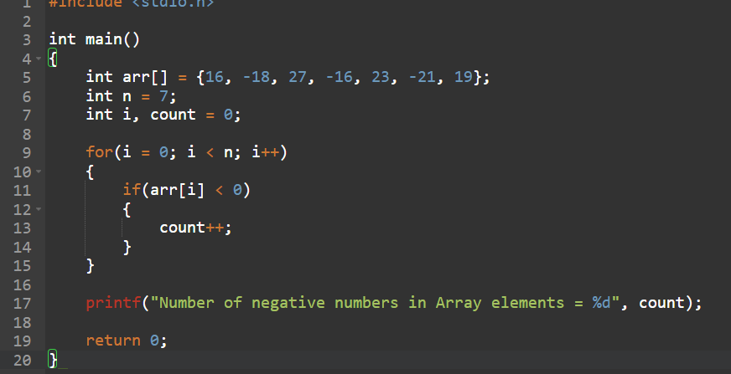

Output:

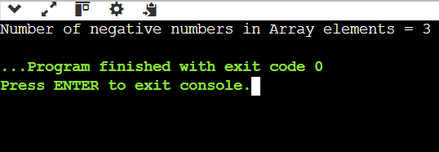

6. Write a program to reverse an array
Sample Input;
Array of elements = {16, 18, 27, 16, 23, 21, 19}
Sample Output:
Reverse Array elements = {19, 21 23, 16, 27, 18, 16}
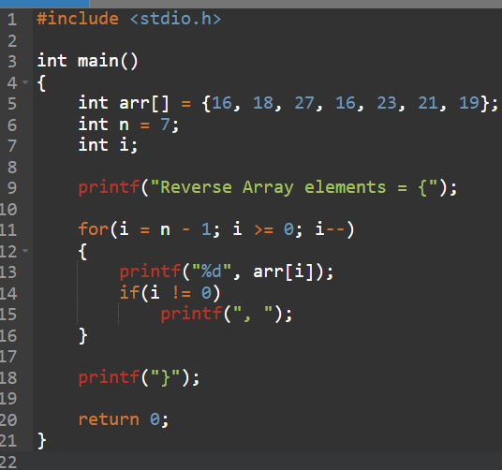
Output:

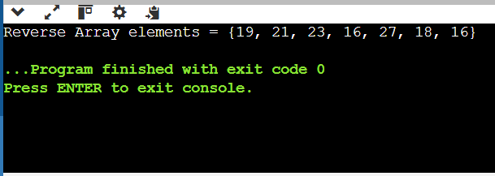
7. Write a program to search the given element and display its position in a linear array.
Sample Input;:
Array of elements = {16, 18, 27, 16, 23, 21, 19}
Element to search = 23
Sample Output:
Given element 23 is found at 5 th position
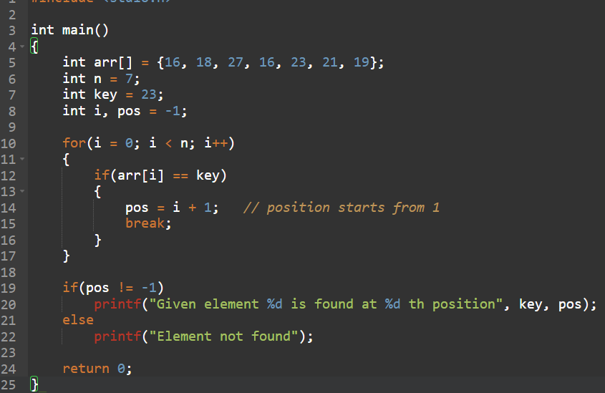
Output:

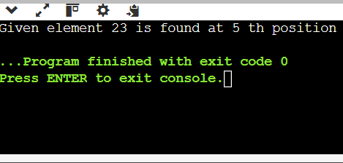
8. Program to remove duplicates from the sorted array
Sample Input:
Array = {15, 14, 25, 14, 32, 14, 31}
Sample Output:
Removed Array = {14, 15, 25, 31, 32}
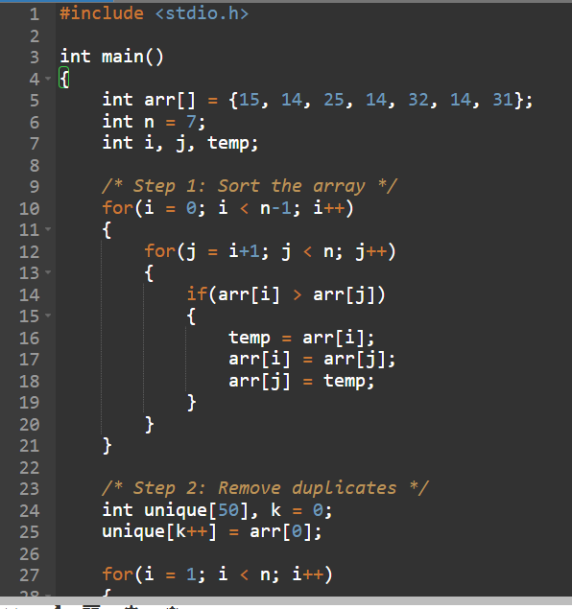
Output:

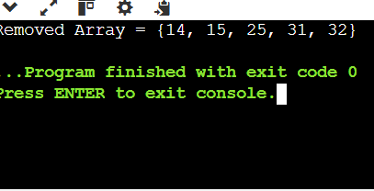

9. Write a Program to find the sum and average of numbers in a matrix format of array
Sample input:
1 2 3
4 5 6
7 8 9
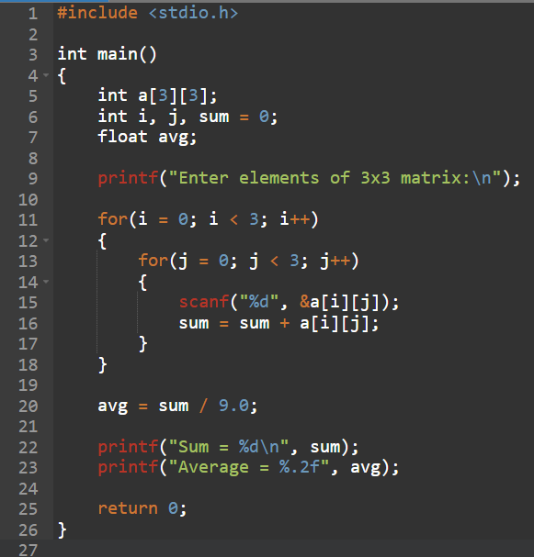
Output:

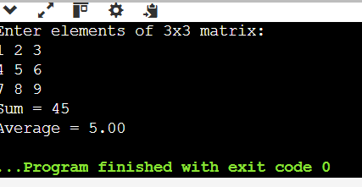

10. Write a program for matrix Multiplication?
Sample Input:
Mat1 = 1 2
5 3
Mat2 = 2 3
4 11
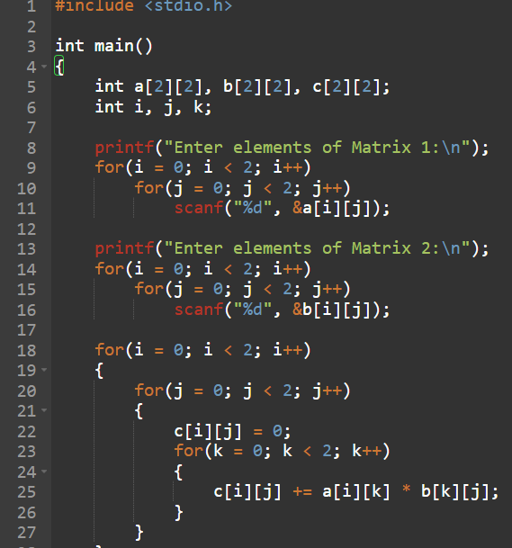
Output:

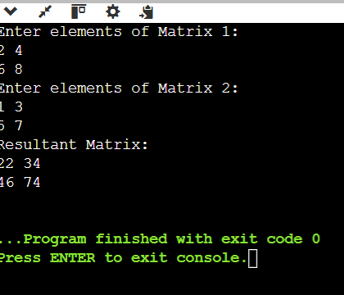
11. The transpose of a matrix is found by interchanging its rows into columns or columns
into rows. Write a program to find the Transpose of a given Matrix.
Sample input:
1 2
5 3
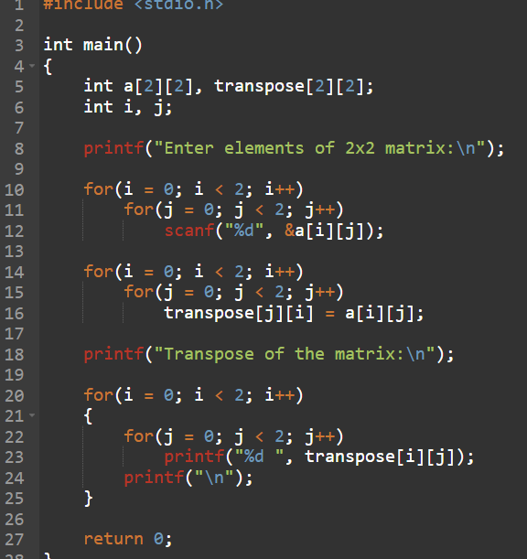
Output:
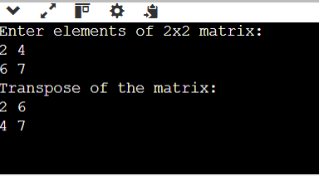
12. Program to find the Sum of each Row and each Column of a Matrix.

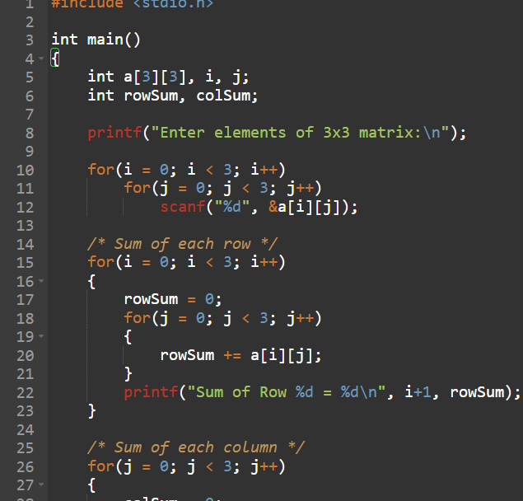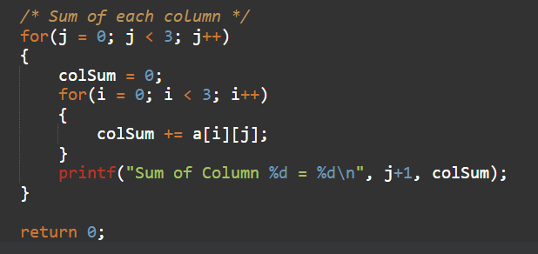
Output:
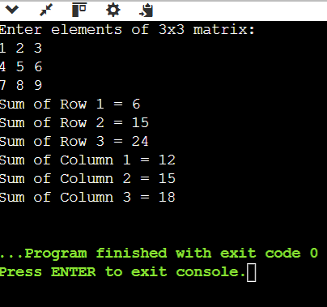

13. C Program for Array Rotation (rotate array of size n by d elements)
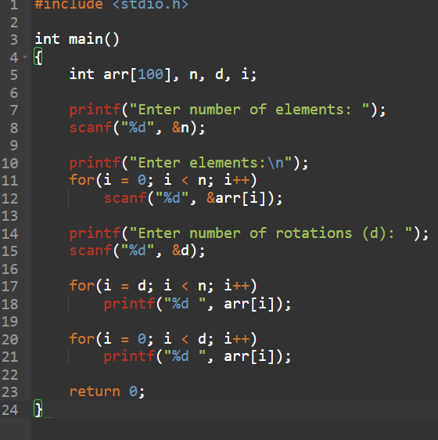
Output:

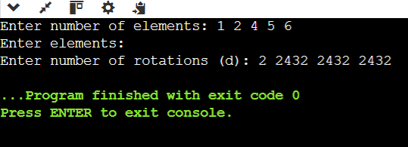

14. C Program for Second min element in an array
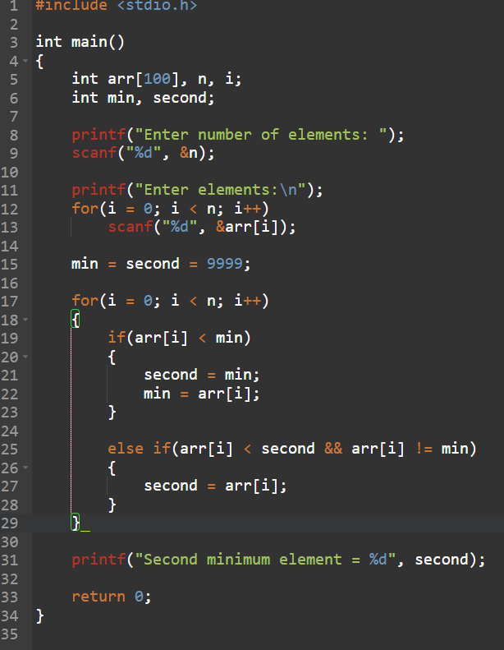
Output:

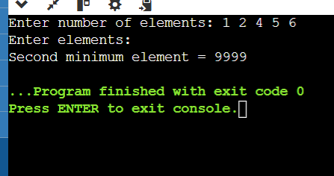

15. C Program for Kth min in an array’
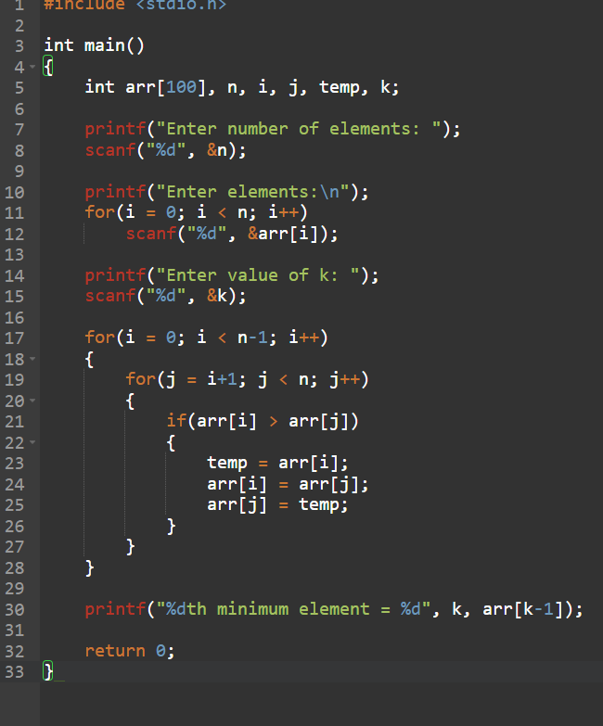
Output:

